KIDS LEARNING GAME

*Final Report*

**

*PYTHON PROJECT*

*BY*

|  |  |  |
| --- | --- | --- |
| **Registration No.** | **Name** | **Roll No.** |
| 12109595 | Anurag Kumar | RK21NDB37 |
| 12113490 | Harshit Kumar Pandey | RK21NDB53 |
| 12109409 | Adarsh Singh | RK21NDA08 |

Under the guidance of

**Dr. Deepika Ghai**



**School of Computer Science and Engineering**

Lovely Professional University Phagwara, Punjab (India)

NOV 2022

**ACKNOWLEDGMENT**

Place : Lovely Professional University

Date : 15th November, 2022

We would like to thank Dr. Deepika Ghai for assigning us with this project. Through the project we are able to grasp more technical and have a hands-on practical experience with python projects. Through it we are able to learn how a project is created and how necessary and crucial technical knowledge is. We are really grateful to the faculty that has provided us with the necessary guidelines.

|  |  |
| --- | --- |
| **Name** | **Registration No.** |
| Anurag Kumar | 12109595 |
| Harshit Kumar Pandey | 12113490 |
| Adarsh Singh | 12109409 |

**DECLARATION STATEMENT**

Place : Lovely Professional University Date : 15th November, 2022

This is to declare that this report has been written by us. No part of the report is copied from the other sources. All information included from other sources has been duly acknowledged. We aver that if any part of the report is found to be copied, we will take full responsibility for it.

Name: Anurag Kumar

Reg. No. : 12109595

Signature :………………

Name : Harshit Kumar Pandey

Reg. No. : 12113490

Signature :………………..

Name : Adarsh Singh

Reg. No. : 12109409

Signature :……………….

**TABLE OF CONTENTS**

***CONTENTS PAGE NO.***

1. INTRODUCTION 7
   1. Introduction 7
   2. Uses 7
   3. Special Button 7
2. METHODOLOGY 11
   1. Requirements 11
   2. Functionality 11
   3. Implementation 13
   4. Debugging 13
   5. Execution 13
   6. Working 13
3. TECHNOLOGY 18
   1. Python 3.7 18
   2. GUI 18
   3. IDE 18
   4. Tkinter 18
   5. Widgets classes 18
   6. Option with values 18
4. WORK DIVISION 19
5. CODE…………………...….……………………………………………..21
6. REFERENCES 49

|  |  |  |  |
| --- | --- | --- | --- |
|  | | **LIST OF TABLES** |  |
| ***Table No.*** | ***Name*** |  | ***Page No.*** |
| 4.1 | Gantt Chart |  | 20 |
| 4.2 | Work Division |  | 20 |

**LIST OF FIGURES**

|  |  |  |
| --- | --- | --- |
| ***Fig No.*** | ***Name*** | ***Page No.*** |
| 1.3.1 | Start now button | 7 |
| 1.3.2 | Image button | 8 |
| 1.3.3 | Parrot button | 8 |
| 1.3.4 | Exit button | 9 |
| 1.3.5 | Submit button | 9 |
| 1.3.6 | Home button | 10 |
| 1.3.7 | Ok button | 10 |
| 1.3.8 | Message box | 10 |
| 2.6.1 | About us home page | 14 |
| 2.6.2 | KLG home page | 14 |
| 2.6.3 | 12 Images | 15 |
| 2.6.4 | Checkbox | 15 |
| 2.6.5 | Checkbox with messagebox | 16 |
| 2.6.6 | Checkbox with thank you image | 16 |
| 2.6.7 | Flow chart | 17 |

# Introduction

**CHAPTER 1 INTRODUCTION**

Based on Image Recognition, a game is designed in which the kids will sees the various images for some particular time duration and after that they have to recognize them by the names of images.

# Uses

By developing this game, we will predict the number of images` that are correctly recognized by a user from total number of images.

All the button used in this project perform some special kind of operations.

* Start the game
* Continue the playing
* Exit from the program
* Returning the total number of images that are correctly recognize
* Printing the total number of images that are correctly recognize Button used in this project are like EXIT, START, OK, SUBMIT etc.

# Special Button

Kids Learning Game uses some buttons. All the button used in this program are

* START NOW
* EXIT
* OK
* SUBMIT
* HOME
* IMAGE BUTTON

**START NOW**



Fig 1.3.1

Code we used in our program…

Button(about_us_window3, image=start, command=home_page).pack(anchor=NW, padx=200, pady=30)

This button is defined in the in the program named “about_us.py”.

This button starts our program.

On clicking on this button, we will go to the program name “klg.py” from “about_us.py”.

**IMAGE BUTTON**

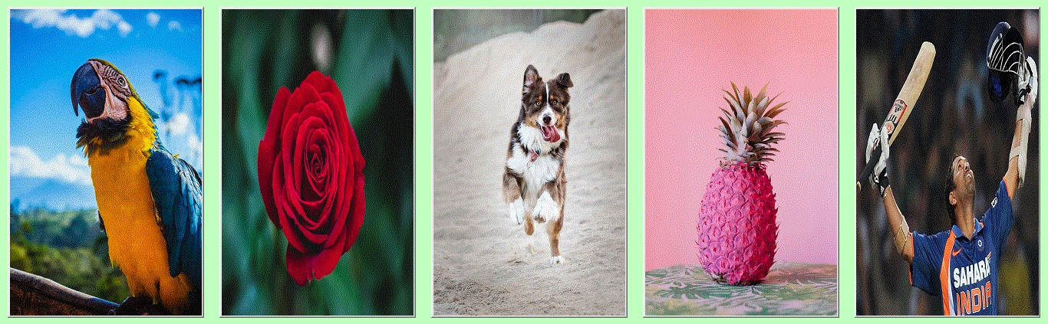

Fig 1.3.2

Code we used in our program…

Button(frame1, image=homebird, command=birds).pack(side=LEFT, padx=10) Button(frame1, image=homeflower, command=flowers).pack(side=LEFT, padx=10) Button(frame1, image=homeanimal, command=animals).pack(side=LEFT, padx=10) Button(frame1, image=homefruit, command=fruits).pack(side=LEFT, padx=10) Button(frame1, image=homeplayer, command=players).pack(side=LEFT, padx=10)

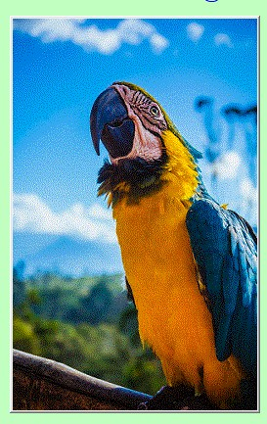Fig 1.3.3

Code we used in our program…

Button(frame1, image=homebird, command=birds).pack(side=LEFT, padx=10)

This button is defined in the in the program named “about_us.py”. There are five button we used here. This button are the images.

On clicking any of the image we will see 12 images. The images we can see according to the image we click

For example, if we click on flower, we can see 12 different flowers.

**EXIT**

Fig 1.3.4

Code we used in our program…

Button(frame3, text="EXIT", bg="darksalmon", fg="yellow", bd=3, cursor="arrow", command=exit).pack(side=LEFT, padx=10, pady=25, ipadx=30)

This button is defined in the in the program named “klg.py”.

On clicking on this button, we will exit from the program and no further execution is done.

**OK**

Fig 1.3.5

There are two OK buttons is used in this project. Code we used in our program…

Button(frame1, text="OK", bg="darksalmon", fg="yellow", bd=3, cursor="arrow", command=okProcess).grid(row=3, column=4, sticky=W, padx=10, pady=10, ipadx=30)

This button is defined in the in the program named “klg.py”.

On clicking on this button means continue the game. We will see list of 20 images name. We can select the name and go to SUBMIT button.

**SUBMIT**

Fig 1.3.6

Code we used in our program…

Button(frame2, text="SUBMIT", bg="darksalmon", fg="yellow", bd=3, cursor="arrow", command=printing).grid(row=5, column=1, padx=10, pady=10, ipadx=20)

This button is defined in the in the program named “klg.py”.

On clicking this button, a messagebox will appear where we can see the total number of images correctly recognize.

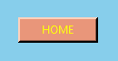**HOME**

Fig 1.3.7

Code we used in our program…

Button(frame2, text="HOME", bg="darksalmon", fg="yellow", bd=3, cursor="arrow", command=home).grid(row=1, column=6, padx=200, pady=10, ipadx=20)

This button is defined in the in the program named “klg.py”.

On clicking on this button, we will go to the program name “about_us.py” from “klg.py”.

**OK**

Fig 1.3.8

No code is there to use this button. This button is present on message box.

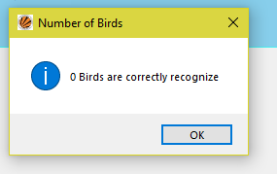Fig 1.3.9

On clicking this button, we will get percentage of accuracy.

**CHAPTER 2 METHODOLOGY**

# Requirements

First step is gathering our requirements of the project. The functions and the modules and the necessary for the development of the project.

# Functionality

In this step we will discuss the different function used in the program and how they are working.

The different types of function we used are…

* home_page()
* birds()
* flowers()
* animals()
* fruits()
* players()
* okProcess()
* counting()
* printing()
* home()

Now we will discuss working of each of the function.

**home_page()**

This function is defined in the program named “about_us.py”. Code we used is…

def home_page(): about_us_window.destroy() import os os.system("python klg.py")

Working of this function is to destroy the current window and move to new program

named “klg.py”.

**birds()**

This function is defined in the program named “klg.py”.

Working of this function is to destroy the current window and display a new window with 12 images and some text and some button.

**flowers()**

This function is defined in the program named “klg.py”.

Working of this function is to destroy the current window and display a new window with 12 images and some text and some button.

**animals()**

This function is defined in the program named “klg.py”.

Working of this function is to destroy the current window and display a new window with 12 images and some text and some button.

**friuts()**

This function is defined in the program named “klg.py”.

Working of this function is to destroy the current window and display a new window with 12 images and some text and some button.

**players()**

This function is defined in the program named “klg.py”.

Working of this function is to destroy the current window and display a new window with 12 images and some text and some button.

**okProcess()**

This function is defined in the program named “klg.py”.

This function destroys the current frame. After that a list of 20 images name will appear including the image that are previously shown.

**counting()**

This function is defined in the program named “klg.py”. Code we use is…

def counting():

count = v1.get() + v2.get() + v3.get() + v4.get() + v5.get() + v6.get() + v7.get() + v8.get() + v9.get() + v10.get() + v11.get() + v12.get()

return count

This function returns the number of images that are correctly selected.

**printing()**

This function is defined in the program named “klg.py”. Code we used is…

def printing():

messagebox.showinfo("Number of Birds", str(counting()) + " Birds are correctly recognize")

L = Label(frame2, bg="skyblue", fg="black", font="gabriola 30 italic underline")

L.grid(row=5, column=2, columnspan=15)

L.config(text="Percentage of Accuracy is " + str("%.2f" % ((counting() * 100) / 12)) + "%")

Label(frame3, image=smile).grid(row=1, column=1, padx=100, pady=50)

Label(frame3, text="Thank You !!!", bg="#46f0f0", fg="blue", font="chaurcer 25 italic").grid(row=1, column=2, sticky=N, pady=180)

Label(frame3, text="Press EXIT to end Playing...", bg="#46f0f0", fg="blue", font="garamond 30 italic").grid(row=2, column=1, sticky=W, padx=10, pady=10)

Button(frame3, text="EXIT", bg="darksalmon", fg="yellow", bd=3, cursor="arrow", command=exit).grid(row=2, column=2, sticky=W, padx=10, pady=10, ipadx=30)

This function shows a messagebox with total number of images that are correctly

recognize. And it will also print the percentage of accuracy.

**home()**

This function is defined in the program named “klg.py”. Code we used is…

def home():

window1.destroy() import os

os.system("python about_us.py")

This function destroys the current window and move to the new program named

“about_us.py”.

# Implementation

This step is to implementing the project by coding. This is most important part of the program. A particular care should be done in order to get error free program.

# Debugging

This step is to check the project for any errors in the code. And linking of the module take place after checking individual modules and functions.

# Execution

This step is to executing the project and simple testing.

# Working

We have used tkinter library to develop GUI for the project. We import sys library to know the current version we are using. We import messagebox from tkinter to show information.

We import os for linking a program with another program.

The detail description about the working of the project is discussing now. On running the program name “about_us.py” we will see the interface like this

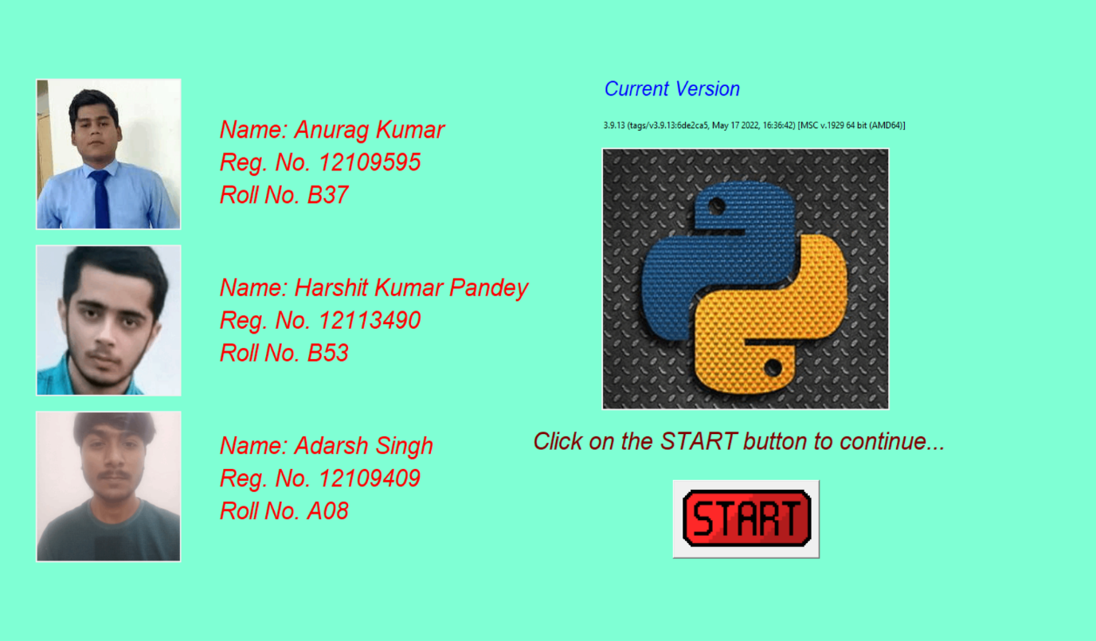

Fig 2.6.1

On clicking the start button, current window is destroyed and move to the program named “klg.py”. The interface will look like this

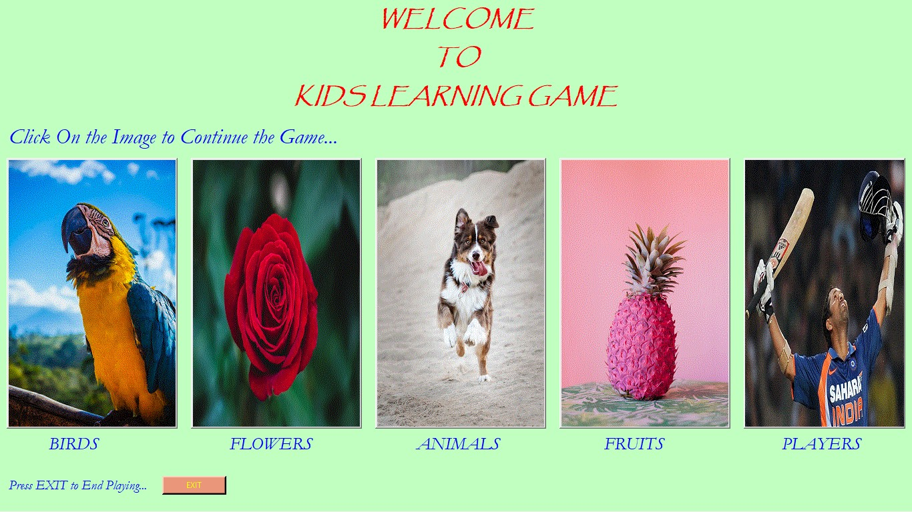

Fig 2.6.2

These five images are the button. On clicking any of the one we will move to the next window.

If we click on EXIT button, we will exit from the program and no further processing is done.

We will discuss the things that happen on click BIRDS image i.e. Parrot. On clicking it we will destroy the current window and next interface will look like this

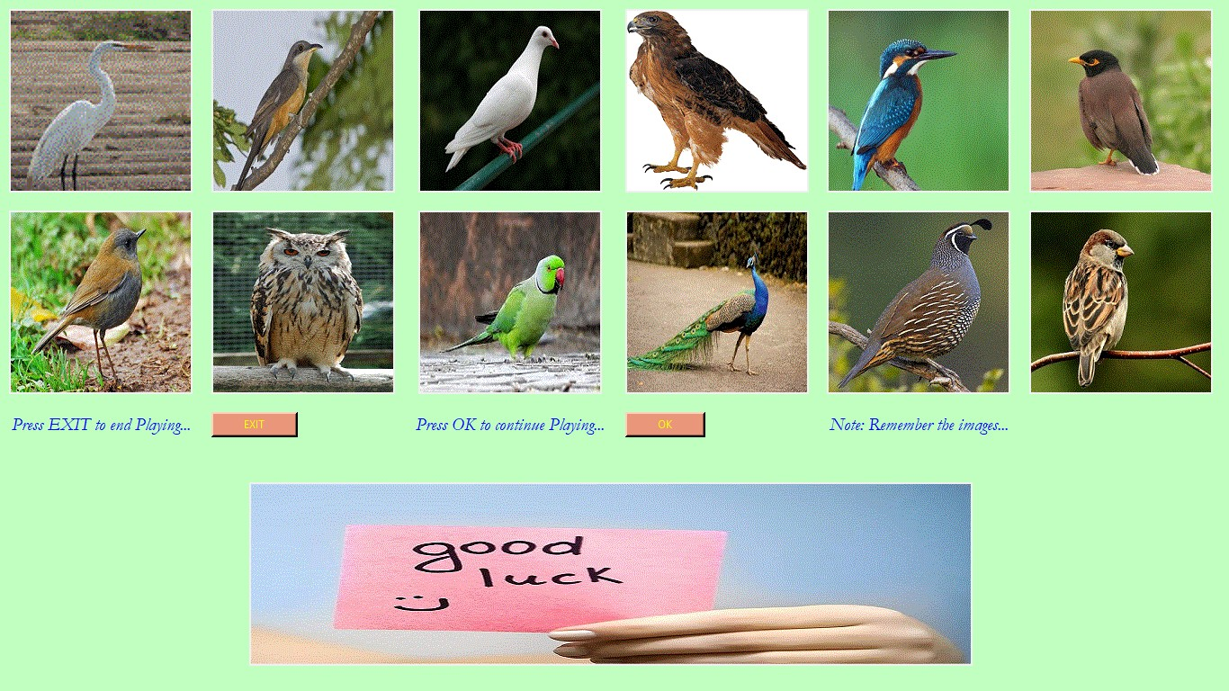

Fig 2.6.3

If we click on EXIT button, we will exit from the program and no further processing is done.

On click OK button current frame is destroy and we get a new interface like this

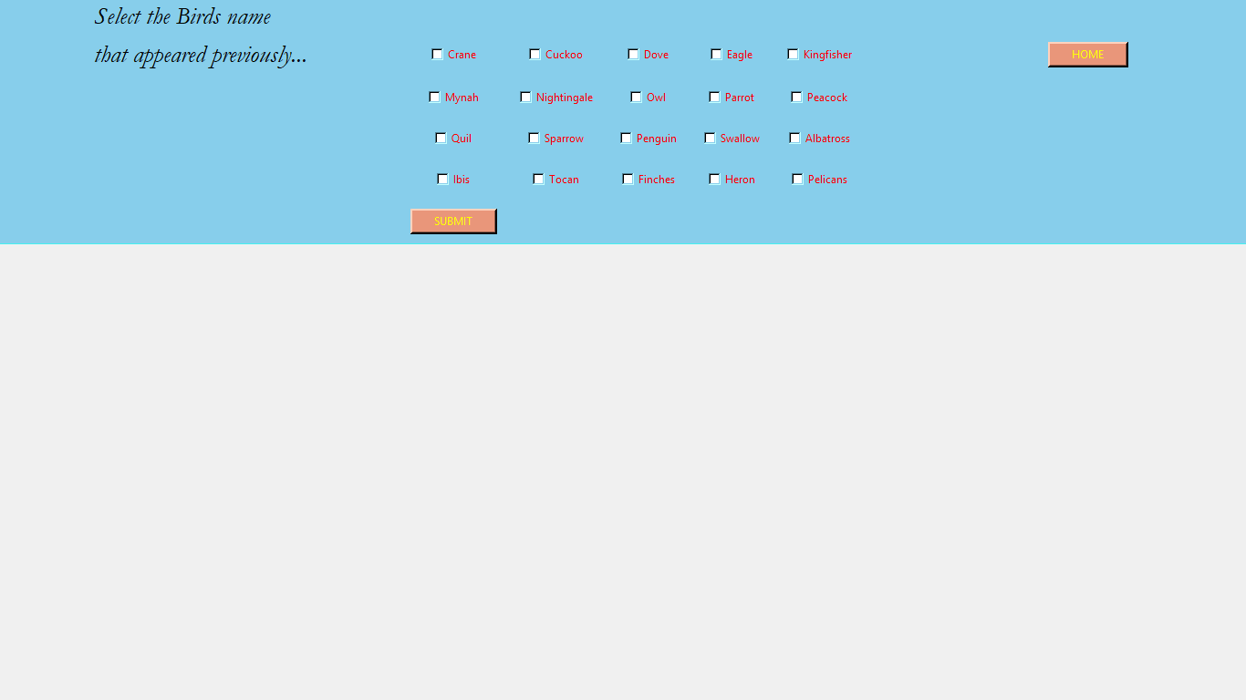

Fig 2.6.4

After selecting the images name, click on the SUBMIT button. The interface will look like

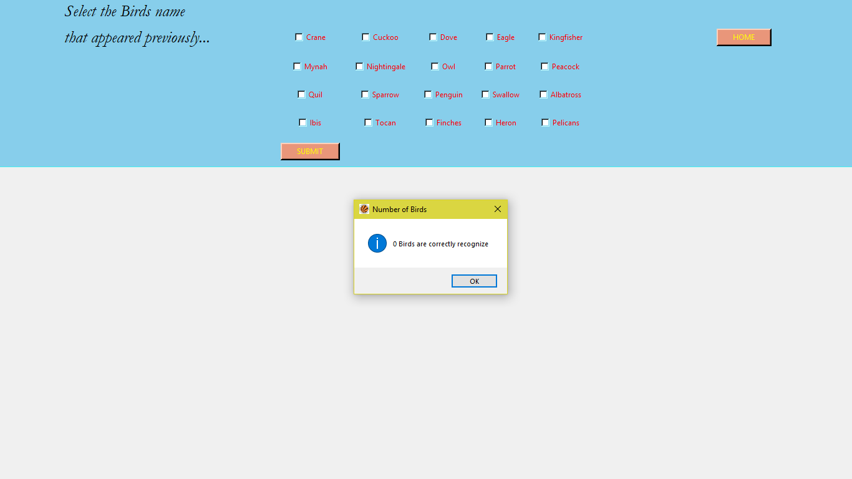

Fig 2.6.5

On clicking OK button, we will get the accuracy of the image i.e. number of images that are correctly recognize and the interface will look like this

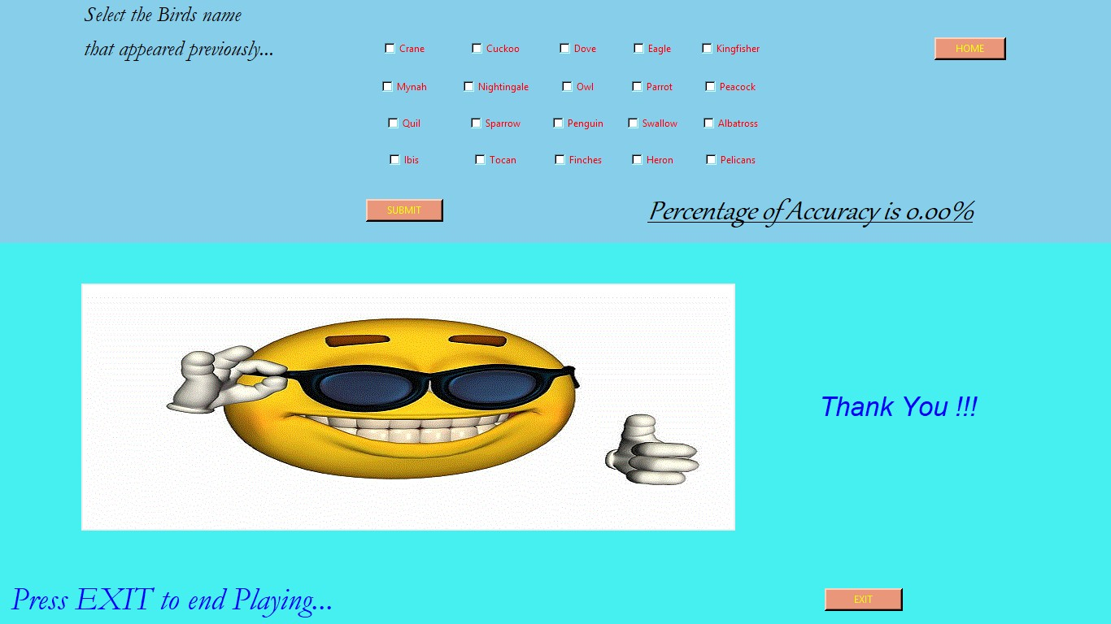

Fig 2.6.6

If we click on EXIT button, we will exit from the program and no further processing is done.

If we click on the HOME button, current window will destroy and we move to the program name “about_us.py”. The same thing will happen again.

**Flow Chart**

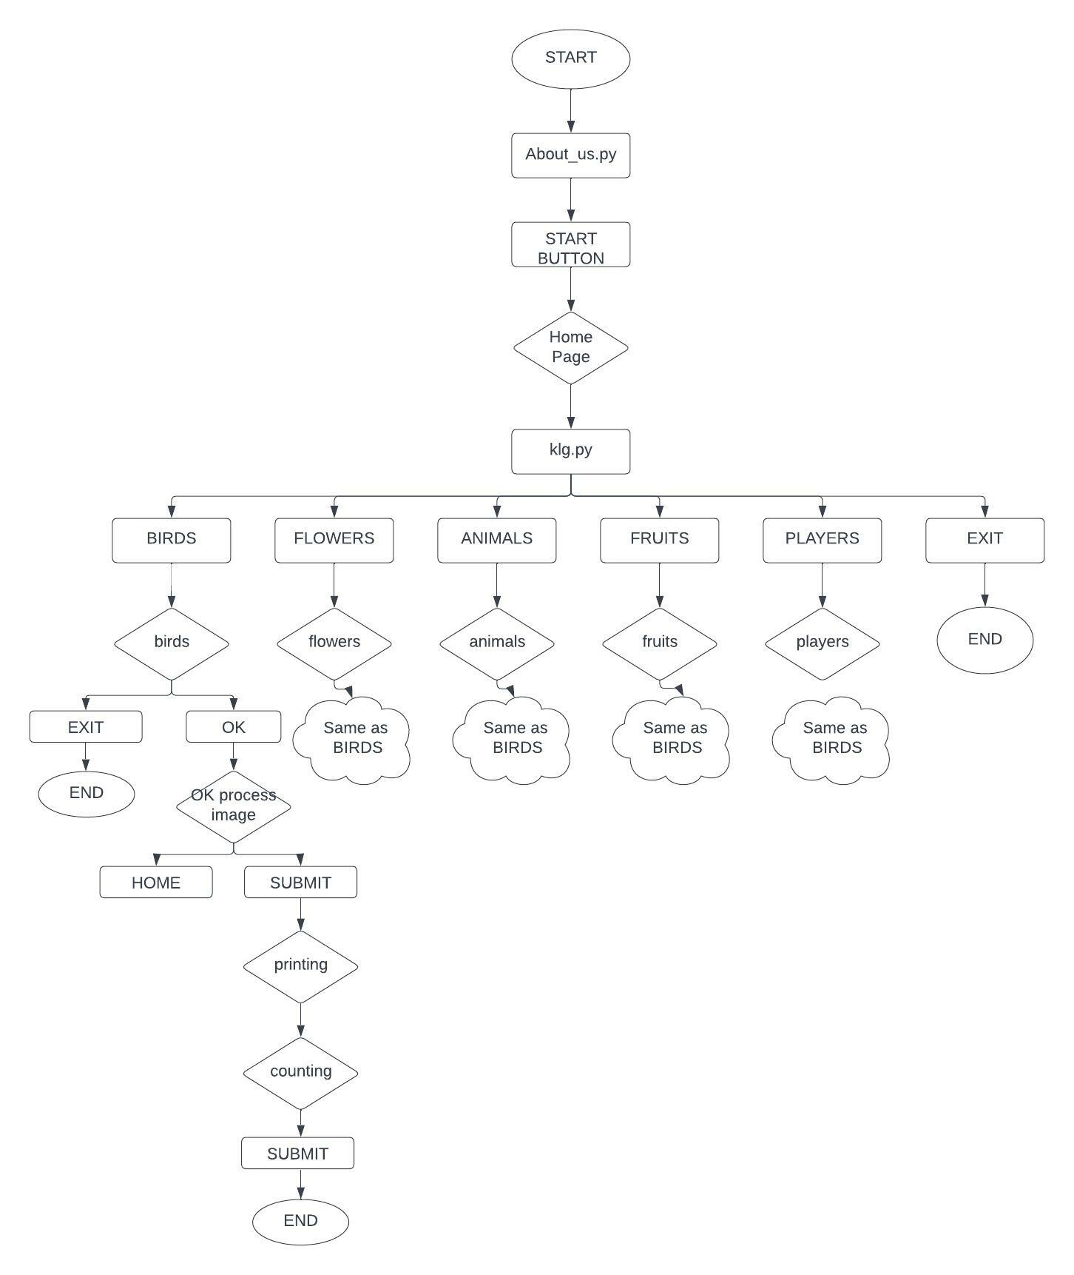

**Fig 2.6.7**

**CHAPTER 3 TECHNOLOGY USED**

# Python 3.7

Python is an interpreted, object-oriented, high-level programming language with dynamic semantics. Its high-level built in data structures, combined with dynamic typing and dynamic binding, make it very attractive for Rapid Application Development, as well as for use as a scripting or glue language to connect existing components together.

Python's simple, easy to learn syntax emphasizes readability and therefore reduces the cost of program maintenance. Python supports modules and packages, which encourages program modularity and code reuse.

* 1. **GUI**

Short for Graphical User Interface, a GUI (pronounced as either G-U-I or gooey) allows the use of icons or other visual indicators to interact with electronic devices, rather than using only text via the command line.

A GUI uses icons, and menus to carry out commands, such as opening, deleting, and moving files.

* 1. **IDE**

Integrated development environment (IDE) used is PyCharm. It provides code analysis, a graphical debugger, an integrated unit tester etc.

* 1. **Tkinter**

Python offers multiple options for developing GUI. Out of all the GUI methods, tkinter is most commonly used method. It is a standard Python interface to the Tk GUI toolkit shipped with Python. Python with tkinter outputs the fastest and easiest way to create the GUI applications.

* 1. **Widgets classes**

Tkinter’s GUI classes define common GUI widgets such as button, labels, check buttons, frames, canvases and other. We will use some of them in our project.

* 1. **Option with values**

Widgets classes contains option with their values to change the interface of the widgets classes means appearance of the window. Some of the option are width, height, fg, bg, side, row, column, text, onvalue, offvalue, variable, expand, fill, file, image, command and so on.

**CHAPTER 4 WORK DIVISION**

We divide the project into three modules. Each module is designed by one of us.

**Module-1**

*Module Name:-* About Us home page & Displaying Image

*Member Name:-* Anurag Kumar

*Description:-*First of all import all the definitions from tkinter. Title is given by using title widgets. Created window named as about_us_window. He created three more frames named as about_us_window1, about_us_window2 and about_us_window3 and pack them on about_us_window. He created three PhotoImage object and place them on about_us_window1. Description about the images is pack on the about_us_window2. A photoimage object and a START button is created and placed on about_us_window3. Those things are in the program named as “about-us.py”.

He displays the 12 images on the window named as window1 and it is present on the program named as “klg.py”. He created an OK button and EXIT button. A good luck image is pack on this frame.

Widgets and option used are…

* Title
* Frame-bg, cursor
* Pack-fill, expand, padx, pady
* Grid-row, column, rowspan, columnspan, padx, pady, ipadx, ipady
* PhotoImage-file
* Button-text, padx, pady, ipadx, ipady, command
* Label-text, fg, bg, font

**Module-2**

*Module Name:-*Kids Learning Game home page.

*Member Name:-* Harshit Kumar Pandey

*Description:-*He created the home page of program named as “klg.py”. He created five objects of the five images and pack them on the window and those will act as button. A label with some content is created and pack them on window. A EXIT button is created to exit from program.

Widgets and option used are…

* Button-text, fg, bg, command
* Frame- bg, cursor
* Pack-side, fill, anchor, padx, pady
* Photoimage-file
* Label-text, fg, bg, text

**Module-3**

*Module Name:-*Listing the image name & Finding accuracy

*Member Name:-* Adarsh Singh

*Description:-*He created 20 check button and grid them on window. Each check button will return the value other 1 or 0.

A HOME button is created to go to the program named as “about_us.py”.

He made the logic to show how many images was correctly recognized by user.

A SUBMIT button is place on the frame. On clicking that button a printing() function will call and will return the number of images that are correctly recognize. Config module will show/print the return value.

A thank you image is created and grid it on the window. Widgets and option used are…

* Label-text, fg, bg
* Button-text, bg, fg, command
* Pack-side, fill, anchor, padx, pady
* Config-text
* Photoimage-file

**Gantt Chart**

Each module is/will complete with in the given date as mention below.

|  |  |  |  |  |  |  |
| --- | --- | --- | --- | --- | --- | --- |
| 31/8 | 9/10 | 9/20 | 9/30 | 10/10 | 10/20 | 11/14 |

|  |
| --- |
| Research |
| Initial Report |
| Displaying Image |
| Listing Image Name |
| Recognized Number |
| Final Report |

Table 4.1

**Work Division**

|  |  |  |
| --- | --- | --- |
| S. No. | Student Name | Module Name |
| 1. | Anuarg Kumar | About Us home page & Displaying Image |
| 2. | Hashit Kumar Pandey | Kids Learning Game home page |
| 3. | Adarsh Singh | Listing the image name & Finding accuracy |

Table 4.2

**CHAPTER 5**

**CODE**

**about_us.py // (Current Window)**

def home_page():

    about_us_window.destroy()

    import os

    os.system("python klg.py")

from tkinter import *

import sys

about_us_window = Tk()

about_us_window.title("ABOUT US")

about_us_window.wm_attributes("-fullscreen", "true")

about_us_window.config(bg="aquamarine")

about_us_window.iconbitmap("lpu_logo.ico")

about_us_window1 = Frame(about_us_window, bg="aquamarine")

about_us_window1.pack(side=LEFT)

about_us_window2 = Frame(about_us_window, bg="aquamarine")

about_us_window2.pack(side=LEFT, pady=50)

about_us_window3 = Frame(about_us_window, bg="aquamarine")

about_us_window3.pack(side=LEFT, pady=50)

image1 = PhotoImage(file="anurag.gif")

image2 = PhotoImage(file="pandey.gif")

image3 = PhotoImage(file="adarsh.gif")

Label(about_us_window1, image=image1).pack(padx=50, pady=10)

Label(about_us_window1, image=image2).pack(padx=50, pady=10)

Label(about_us_window1, image=image3).pack(padx=50, pady=10)

Label(about_us_window2, text="Name: Anurag Kumar", font="halston 25 italic", bg="aquamarine", fg="red").pack(anchor=NW)

Label(about_us_window2, text="Reg. No. 12109595", font="halston 25 italic", bg="aquamarine", fg="red").pack(anchor=NW)

Label(about_us_window2, text="Roll No. B37", font="halston 25 italic", bg="aquamarine", fg="red").pack(anchor=NW)

Label(about_us_window2, bg="aquamarine").pack(anchor=NW, pady=30)

Label(about_us_window2, text="Name: Harshit Kumar Pandey", font="halston 25 italic", bg="aquamarine", fg="red").pack(anchor=NW)

Label(about_us_window2, text="Reg. No. 12113490", font="halston 25 italic", bg="aquamarine", fg="red").pack(anchor=NW)

Label(about_us_window2, text="Roll No. B53", font="halston 25 italic", bg="aquamarine", fg="red").pack(anchor=NW)

Label(about_us_window2, bg="aquamarine").pack(anchor=NW, pady=30)

Label(about_us_window2, text="Name: Adarsh Singh", font="halston 25 italic", bg="aquamarine", fg="red").pack(anchor=NW)

Label(about_us_window2, text="Reg. No. 12109409", font="halston 25 italic", bg="aquamarine", fg="red").pack(anchor=NW)

Label(about_us_window2, text="Roll No. A08", font="halston 25 italic", bg="aquamarine", fg="red").pack(anchor=NW)

python = PhotoImage(file="python.gif")

start = PhotoImage(file="start.gif")

Label(about_us_window3, text="Current Version", font="halston 20 italic", bg="aquamarine", fg="blue").pack(anchor=NW, padx=100, pady=20)

Label(about_us_window3, text=sys.version, bg="aquamarine").pack(anchor=NW, padx=100)

Label(about_us_window3, image=python).pack(anchor=NW, padx=100, pady=20)

Label(about_us_window3, text="Click on the START button to continue...", font="halston 25 italic", bg="aquamarine", fg="maroon").pack(anchor=NW)

Button(about_us_window3, image=start, command=home_page).pack(anchor=NW, padx=200, pady=30)

about_us_window.mainloop()

**klg.py (Homepage)**

def birds():

    window.destroy()

    def home():

        window1.destroy()

        import os

        os.system("python about_us.py")

    def okProcess():

        frame1.destroy()

        frame2 = Frame(window1, bg="skyblue", cursor="cross")

        frame2.pack(fill=BOTH, expand=YES)

        frame3 = Frame(window1, bg="#46f0f0", cursor="plus")

        frame3.pack(fill=BOTH)

        from tkinter import messagebox

        def printing():

            messagebox.showinfo("Number of Birds", str(counting()) + " Birds are correctly recognize" + "\n\n" + str(incorrect_counting()) + " Birds are selectled wrongly")

            L = Label(frame2, bg="skyblue", fg="black", font="gabriola 30 italic underline")

            L.grid(row=5, column=2, columnspan=15)

            if counting() > incorrect_counting():

                L.config(text="Percentage of Accuracy is " + str("%.2f" % (((counting() - incorrect_counting()) * 100) / 12)) + "%")

            else:

                L.config(text="Percentage of Accuracy is 0.00%")

            Label(frame3, image=smile).grid(row=1, column=1, padx=100, pady=50)

            Label(frame3, text="Thank You !!!", bg="#46f0f0", fg="blue", font="chaurcer 25 italic").grid(row=1, column=2, sticky=N, pady=180)

            Label(frame3, text="Press EXIT to end Playing...", bg="#46f0f0", fg="blue", font="garamond 30 italic").grid(row=2, column=1, sticky=W, padx=10, pady=10)

            Button(frame3, text="EXIT", bg="darksalmon", fg="yellow", bd=3, cursor="arrow", command=exit).grid(row=2, column=2, sticky=W, padx=10, pady=10, ipadx=30)

        def counting():

            count = v1.get() + v2.get() + v3.get() + v4.get() + v5.get() + v6.get() + v7.get() + v8.get() + v9.get() + v10.get() + v11.get() + v12.get()

            return count

        def incorrect_counting():

            incorrect_count = v13.get() + v14.get() + v15.get() + v16.get() + v17.get() + v18.get() + v19.get() + v20.get()

            return incorrect_count

        v1 = IntVar()

        v2 = IntVar()

        v3 = IntVar()

        v4 = IntVar()

        v5 = IntVar()

        v6 = IntVar()

        v7 = IntVar()

        v8 = IntVar()

        v9 = IntVar()

        v10 = IntVar()

        v11 = IntVar()

        v12 = IntVar()

        v13 = IntVar()

        v14 = IntVar()

        v15 = IntVar()

        v16 = IntVar()

        v17 = IntVar()

        v18 = IntVar()

        v19 = IntVar()

        v20 = IntVar()

        Label(frame2, text="Select maximum 12 Birds name", bg="skyblue", fg="black", font="garamond 20 italic").grid(row=0, column=0, sticky=W, padx=100)

        Label(frame2, text="that appeared previously...", bg="skyblue", fg="black", font="garamond 20 italic").grid(row=1, column=0, sticky=W, padx=100)

        Button(frame2, text="HOME", bg="darksalmon", fg="yellow", bd=3, cursor="arrow", command=home).grid(row=1,

                                                                                                                 column=6,

                                                                                                                 padx=200,

                                                                                                                 pady=10,

                                                                                                                 ipadx=20)

        Checkbutton(frame2, text="Crane", fg="red", bg="skyblue", variable=v1, onvalue=1, offvalue=0, command=counting).grid(row=4, column=5, padx=10, pady=10)

        Checkbutton(frame2, text="Cuckoo", fg="red", bg="skyblue", variable=v2, onvalue=1, offvalue=0, command=counting).grid(row=1, column=2, padx=10, pady=10)

        Checkbutton(frame2, text="Dove", fg="red", bg="skyblue", variable=v3, onvalue=1, offvalue=0, command=counting).grid(row=4, column=2, padx=10, pady=10)

        Checkbutton(frame2, text="Eagle", fg="red", bg="skyblue", variable=v4, onvalue=1, offvalue=0, command=counting).grid(row=1, column=4, padx=10, pady=10)

        Checkbutton(frame2, text="Kingfisher", fg="red", bg="skyblue", variable=v5, onvalue=1, offvalue=0, command=counting).grid(row=1, column=5, padx=10, pady=10)

        Checkbutton(frame2, text="Mynah", fg="red", bg="skyblue", variable=v6, onvalue=1, offvalue=0, command=counting).grid(row=2, column=1, padx=10, pady=10)

        Checkbutton(frame2, text="Nightingale", fg="red", bg="skyblue", variable=v7, onvalue=1, offvalue=0, command=counting).grid(row=3, column=5, padx=10, pady=10)

        Checkbutton(frame2, text="Owl", fg="red", bg="skyblue", variable=v8, onvalue=1, offvalue=0, command=counting).grid(row=2, column=3, padx=10, pady=10)

        Checkbutton(frame2, text="Parrot", fg="red", bg="skyblue", variable=v9, onvalue=1, offvalue=0, command=counting).grid(row=2, column=4, padx=10, pady=10)

        Checkbutton(frame2, text="Peacock", fg="red", bg="skyblue", variable=v10, onvalue=1, offvalue=0, command=counting).grid(row=3, column=3, padx=10, pady=10)

        Checkbutton(frame2, text="Quil", fg="red", bg="skyblue", variable=v11, onvalue=1, offvalue=0, command=counting).grid(row=3, column=2, padx=10, pady=10)

        Checkbutton(frame2, text="Sparrow", fg="red", bg="skyblue", variable=v12, onvalue=1, offvalue=0, command=counting).grid(row=3, column=1, padx=10, pady=10)

        Checkbutton(frame2, text="Penguin", fg="red", bg="skyblue", variable=v13, onvalue=1, offvalue=0, command=incorrect_counting).grid(row=2, column=5, padx=10, pady=10)

        Checkbutton(frame2, text="Swallow", fg="red", bg="skyblue", variable=v14, onvalue=1, offvalue=0, command=incorrect_counting).grid(row=3, column=4, padx=10, pady=10)

        Checkbutton(frame2, text="Albatross", fg="red", bg="skyblue", variable=v15, onvalue=1, offvalue=0, command=incorrect_counting).grid(row=2, column=2, padx=10, pady=10)

        Checkbutton(frame2, text="Ibis", fg="red", bg="skyblue", variable=v16, onvalue=1, offvalue=0, command=incorrect_counting).grid(row=4, column=1, padx=10, pady=10)

        Checkbutton(frame2, text="Tocan", fg="red", bg="skyblue", variable=v17, onvalue=1, offvalue=0, command=incorrect_counting).grid(row=1, column=3, padx=10, pady=10)

        Checkbutton(frame2, text="Finches", fg="red", bg="skyblue", variable=v18, onvalue=1, offvalue=0, command=incorrect_counting).grid(row=4, column=3, padx=10, pady=10)

        Checkbutton(frame2, text="Heron", fg="red", bg="skyblue", variable=v19, onvalue=1, offvalue=0, command=incorrect_counting).grid(row=4, column=4, padx=10, pady=10)

        Checkbutton(frame2, text="Pelicans", fg="red", bg="skyblue", variable=v20, onvalue=1, offvalue=0, command=incorrect_counting).grid(row=1, column=1, padx=10, pady=10)

        Button(frame2, text="SUBMIT", bg="darksalmon", fg="yellow", bd=3, cursor="arrow", command=printing).grid(row=5, column=1, padx=10, pady=10, ipadx=20)

    window1 = Tk()

    window1.title("BIRDS")

    window1.iconbitmap("lpu_logo.ico")

    window1.wm_attributes('-fullscreen', 'true')

    smile = PhotoImage(file="smile.gif")

    good_luck = PhotoImage(file="good_luck.gif")

    image1 = PhotoImage(file="crane.gif")

    image2 = PhotoImage(file="cuckoo.gif")

    image3 = PhotoImage(file="dove.gif")

    image4 = PhotoImage(file="eagle.gif")

    image5 = PhotoImage(file="kingfisher.gif")

    image6 = PhotoImage(file="mynah.gif")

    image7 = PhotoImage(file="nightingale.gif")

    image8 = PhotoImage(file="owl.gif")

    image9 = PhotoImage(file="parrot.gif")

    image10 = PhotoImage(file="peacock.gif")

    image11 = PhotoImage(file="quail.gif")

    image12 = PhotoImage(file="sparrow.gif")

    frame1 = Frame(window1, bg="darkseagreen1", cursor="circle")

    frame1.pack(fill=BOTH)

    Label(frame1, image=image1).grid(row=1, column=1, padx=10, pady=10)

    Label(frame1, image=image2).grid(row=1, column=2, padx=10, pady=10)

    Label(frame1, image=image3).grid(row=1, column=3, padx=10, pady=10)

    Label(frame1, image=image4).grid(row=1, column=4, padx=10, pady=10)

    Label(frame1, image=image5).grid(row=1, column=5, padx=10, pady=10)

    Label(frame1, image=image6).grid(row=1, column=6, padx=10, pady=10)

    Label(frame1, image=image7).grid(row=2, column=1, padx=10, pady=10)

    Label(frame1, image=image8).grid(row=2, column=2, padx=10, pady=10)

    Label(frame1, image=image9).grid(row=2, column=3, padx=10, pady=10)

    Label(frame1, image=image10).grid(row=2, column=4, padx=10, pady=10)

    Label(frame1, image=image11).grid(row=2, column=5, padx=10, pady=10)

    Label(frame1, image=image12).grid(row=2, column=6, padx=10, pady=10)

    Label(frame1, text="Press EXIT to end Playing...", bg="darkseagreen1", fg="blue", font="garamond 15 italic").grid(row=3, column=1, sticky=W, padx=10, pady=10)

    Button(frame1, text="EXIT", bg="darksalmon", fg="yellow", bd=3, cursor="arrow", command=exit).grid(row=3, column=2, sticky=W, padx=10, pady=10,ipadx=30)

    Label(frame1, text="Press OK to continue Playing...", bg="darkseagreen1", fg="blue", font="garamond 15 italic").grid(row=3, column=3, sticky=W, padx=10, pady=10)

    Button(frame1, text="OK", bg="darksalmon", fg="yellow", bd=3, cursor="arrow", command=okProcess).grid(row=3, column=4, sticky=W, padx=10, pady=10, ipadx=30)

    Label(frame1, text="Note: Remember the images...", bg="darkseagreen1", fg="blue",

          font="garamond 15 italic").grid(row=3, column=5, sticky=W, padx=10, pady=10)

    Label(frame1, image=good_luck).grid(row=4, column=1, columnspan=6, pady=40)

    window1.mainloop()

def flowers():

    window.destroy()

    def home():

        window1.destroy()

        import os

        os.system("python about_us.py")

    def okProcess():

        frame1.destroy()

        frame2 = Frame(window1, bg="skyblue", cursor="cross")

        frame2.pack(fill=BOTH, expand=YES)

        frame3 = Frame(window1, bg="#46f0f0", cursor="plus")

        frame3.pack(fill=BOTH)

        from tkinter import messagebox

        def printing():

            messagebox.showinfo("Number of Flowers", str(counting()) + " Flowers are correctly recognize" + "\n" + str(incorrect_counting()) + " Flowers are selectled wrongly")

            L = Label(frame2, bg="skyblue", fg="black", font="gabriola 30 italic underline")

            L.grid(row=5, column=2, columnspan=15)

            if counting() > incorrect_counting():

                L.config(text="Percentage of Accuracy is " + str("%.2f" % (((counting() - incorrect_counting()) * 100) / 12)) + "%")

            else:

                L.config(text="Percentage of Accuracy is 0.00%")

            Label(frame3, image=smile).grid(row=1, column=1, padx=100, pady=50)

            Label(frame3, text="Thank You !!!", bg="#46f0f0", fg="blue", font="chaurcer 25 italic").grid(row=1,

                                                                                                         column=2,

                                                                                                         sticky=N,

                                                                                                         pady=180)

            Label(frame3, text="Press EXIT to end Playing...", bg="#46f0f0", fg="blue", font="garamond 30 italic").grid(

                row=2, column=1, sticky=W, padx=10, pady=10)

            Button(frame3, text="EXIT", bg="darksalmon", fg="yellow", bd=3, cursor="arrow", command=exit).grid(row=2,

                                                                                                               column=2,

                                                                                                               sticky=W,

                                                                                                               padx=10,

                                                                                                               pady=10,

                                                                                                               ipadx=30)

        def counting():

            count = v1.get() + v2.get() + v3.get() + v4.get() + v5.get() + v6.get() + v7.get() + v8.get() + v9.get() + v10.get() + v11.get() + v12.get()

            return count

        def incorrect_counting():

            incorrect_count = v13.get() + v14.get() + v15.get() + v16.get() + v17.get() + v18.get() + v19.get() + v20.get()

            return incorrect_count

        v1 = IntVar()

        v2 = IntVar()

        v3 = IntVar()

        v4 = IntVar()

        v5 = IntVar()

        v6 = IntVar()

        v7 = IntVar()

        v8 = IntVar()

        v9 = IntVar()

        v10 = IntVar()

        v11 = IntVar()

        v12 = IntVar()

        v13 = IntVar()

        v14 = IntVar()

        v15 = IntVar()

        v16 = IntVar()

        v17 = IntVar()

        v18 = IntVar()

        v19 = IntVar()

        v20 = IntVar()

        Label(frame2, text="Select maximum 12 Flowers name", bg="skyblue", fg="black", font="garamond 20 italic").grid(row=0,

                                                                                                              column=0,

                                                                                                              sticky=W, padx=100)

        Label(frame2, text="that appeared previously...", bg="skyblue", fg="black", font="garamond 20 italic").grid(

            row=1, column=0, sticky=W, padx=100)

        Button(frame2, text="HOME", bg="darksalmon", fg="yellow", bd=3, cursor="arrow", command=home).grid(row=1,

                                                                                                           column=6,

                                                                                                           padx=100,

                                                                                                           pady=10,

                                                                                                           ipadx=20)

        Checkbutton(frame2, text="Ageratum", fg="red", bg="skyblue", variable=v1, onvalue=1, offvalue=0,

                    command=counting).grid(row=4, column=5, padx=10, pady=10)

        Checkbutton(frame2, text="Allium", fg="red", bg="skyblue", variable=v2, onvalue=1, offvalue=0,

                    command=counting).grid(row=1, column=2, padx=10, pady=10)

        Checkbutton(frame2, text="Alstromeria", fg="red", bg="skyblue", variable=v3, onvalue=1, offvalue=0,

                    command=counting).grid(row=4, column=2, padx=10, pady=10)

        Checkbutton(frame2, text="Alyssum", fg="red", bg="skyblue", variable=v4, onvalue=1, offvalue=0,

                    command=counting).grid(row=1, column=4, padx=10, pady=10)

        Checkbutton(frame2, text="Amarylis", fg="red", bg="skyblue", variable=v5, onvalue=1, offvalue=0,

                    command=counting).grid(row=1, column=5, padx=10, pady=10)

        Checkbutton(frame2, text="Anemone", fg="red", bg="skyblue", variable=v6, onvalue=1, offvalue=0,

                    command=counting).grid(row=2, column=1, padx=10, pady=10)

        Checkbutton(frame2, text="Angelica", fg="red", bg="skyblue", variable=v7, onvalue=1, offvalue=0,

                    command=counting).grid(row=3, column=5, padx=10, pady=10)

        Checkbutton(frame2, text="Balloon flower", fg="red", bg="skyblue", variable=v8, onvalue=1, offvalue=0,

                    command=counting).grid(row=2, column=3, padx=10, pady=10)

        Checkbutton(frame2, text="Baneberry", fg="red", bg="skyblue", variable=v9, onvalue=1, offvalue=0,

                    command=counting).grid(row=2, column=4, padx=10, pady=10)

        Checkbutton(frame2, text="Basket of gold", fg="red", bg="skyblue", variable=v10, onvalue=1, offvalue=0,

                    command=counting).grid(row=3, column=3, padx=10, pady=10)

        Checkbutton(frame2, text="Bloodroot", fg="red", bg="skyblue", variable=v11, onvalue=1, offvalue=0,

                    command=counting).grid(row=3, column=2, padx=10, pady=10)

        Checkbutton(frame2, text="Rose", fg="red", bg="skyblue", variable=v12, onvalue=1, offvalue=0,

                    command=counting).grid(row=3, column=1, padx=10, pady=10)

        Checkbutton(frame2, text="Lily", fg="red", bg="skyblue", variable=v13, onvalue=1, offvalue=0, command=incorrect_counting).grid(row=2, column=5, padx=10, pady=10)

        Checkbutton(frame2, text="Baby's breath", fg="red", bg="skyblue", variable=v14, onvalue=1, offvalue=0, command=incorrect_counting).grid(row=3, column=4, padx=10, pady=10)

        Checkbutton(frame2, text="Crocus", fg="red", bg="skyblue", variable=v15, onvalue=1, offvalue=0, command=incorrect_counting).grid(row=2, column=2, padx=10, pady=10)

        Checkbutton(frame2, text="Orchid", fg="red", bg="skyblue", variable=v16, onvalue=1, offvalue=0, command=incorrect_counting).grid(row=4, column=1, padx=10, pady=10)

        Checkbutton(frame2, text="Lotus", fg="red", bg="skyblue", variable=v17, onvalue=1, offvalue=0, command=incorrect_counting).grid(row=1, column=3, padx=10, pady=10)

        Checkbutton(frame2, text="Daffodil", fg="red", bg="skyblue", variable=v18, onvalue=1, offvalue=0, command=incorrect_counting).grid(row=4, column=3, padx=10, pady=10)

        Checkbutton(frame2, text="Dahlia", fg="red", bg="skyblue", variable=v19, onvalue=1, offvalue=0, command=incorrect_counting).grid(row=4, column=4, padx=10, pady=10)

        Checkbutton(frame2, text="Larkspur", fg="red", bg="skyblue", variable=v20, onvalue=1, offvalue=0, command=incorrect_counting).grid(row=1, column=1, padx=10, pady=10)

        Button(frame2, text="SUBMIT", bg="darksalmon", fg="yellow", bd=3, cursor="arrow", command=printing).grid(row=5,

                                                                                                                 column=1,

                                                                                                                 padx=10,

                                                                                                                 pady=10,

                                                                                                                 ipadx=20)

    window1 = Tk()

    window1.title("FLOWERS")

    window1.iconbitmap("lpu_logo.ico")

    window1.wm_attributes('-fullscreen', 'true')

    smile = PhotoImage(file="smile.gif")

    good_luck = PhotoImage(file="good_luck.gif")

    image1 = PhotoImage(file="ageratum.gif")

    image2 = PhotoImage(file="allium.gif")

    image3 = PhotoImage(file="alstromeria.gif")

    image4 = PhotoImage(file="alyssum.gif")

    image5 = PhotoImage(file="amarylis.gif")

    image6 = PhotoImage(file="anemone.gif")

    image7 = PhotoImage(file="angelica.gif")

    image8 = PhotoImage(file="balloon-flower.gif")

    image9 = PhotoImage(file="baneberry.gif")

    image10 = PhotoImage(file="basket-of-gold.gif")

    image11 = PhotoImage(file="bloodroot.gif")

    image12 = PhotoImage(file="rose.gif")

    frame1 = Frame(window1, bg="darkseagreen1", cursor="circle")

    frame1.pack(fill=BOTH)

    Label(frame1, image=image1).grid(row=1, column=1, padx=10, pady=10)

    Label(frame1, image=image2).grid(row=1, column=2, padx=10, pady=10)

    Label(frame1, image=image3).grid(row=1, column=3, padx=10, pady=10)

    Label(frame1, image=image4).grid(row=1, column=4, padx=10, pady=10)

    Label(frame1, image=image5).grid(row=1, column=5, padx=10, pady=10)

    Label(frame1, image=image6).grid(row=1, column=6, padx=10, pady=10)

    Label(frame1, image=image7).grid(row=2, column=1, padx=10, pady=10)

    Label(frame1, image=image8).grid(row=2, column=2, padx=10, pady=10)

    Label(frame1, image=image9).grid(row=2, column=3, padx=10, pady=10)

    Label(frame1, image=image10).grid(row=2, column=4, padx=10, pady=10)

    Label(frame1, image=image11).grid(row=2, column=5, padx=10, pady=10)

    Label(frame1, image=image12).grid(row=2, column=6, padx=10, pady=10)

    Label(frame1, text="Press EXIT to end Playing...", bg="darkseagreen1", fg="blue", font="garamond 15 italic").grid(

        row=3, column=1, sticky=W, padx=10, pady=10)

    Button(frame1, text="EXIT", bg="darksalmon", fg="yellow", bd=3, cursor="arrow", command=exit).grid(row=3, column=2,

                                                                                                       sticky=W,

                                                                                                       padx=10, pady=10,

                                                                                                       ipadx=30)

    Label(frame1, text="Press OK to continue Playing...", bg="darkseagreen1", fg="blue",

          font="garamond 15 italic").grid(row=3, column=3, sticky=W, padx=10, pady=10)

    Button(frame1, text="OK", bg="darksalmon", fg="yellow", bd=3, cursor="arrow", command=okProcess).grid(row=3,

                                                                                                          column=4,

                                                                                                          sticky=W,

                                                                                                          padx=10,

                                                                                                          pady=10,

                                                                                                          ipadx=30)

    Label(frame1, text="Note: Remember the images...", bg="darkseagreen1", fg="blue",

          font="garamond 15 italic").grid(row=3, column=5, sticky=W, padx=10, pady=10)

    Label(frame1, image=good_luck).grid(row=4, column=1, columnspan=6, pady=40)

    window1.mainloop()

def animals():

    window.destroy()

    def home():

        window1.destroy()

        import os

        os.system("python about_us.py")

    def okProcess():

        frame1.destroy()

        frame2 = Frame(window1, bg="skyblue", cursor="cross")

        frame2.pack(fill=BOTH, expand=YES)

        frame3 = Frame(window1, bg="#46f0f0", cursor="plus")

        frame3.pack(fill=BOTH)

        from tkinter import messagebox

        def printing():

            messagebox.showinfo("Number of Animals", str(counting()) + " Animals are correctly recognize" + "\n" + str(incorrect_counting()) + " Animals are selectled wrongly")

            L = Label(frame2, bg="skyblue", fg="black", font="gabriola 30 italic underline")

            L.grid(row=5, column=2, columnspan=15)

            if counting() > incorrect_counting():

                L.config(text="Percentage of Accuracy is " + str("%.2f" % (((counting() - incorrect_counting()) * 100) / 12)) + "%")

            else:

                L.config(text="Percentage of Accuracy is 0.00%")

            Label(frame3, image=smile).grid(row=1, column=1, padx=100, pady=50)

            Label(frame3, text="Thank You !!!", bg="#46f0f0", fg="blue", font="chaurcer 25 italic").grid(row=1,

                                                                                                         column=2,

                                                                                                         sticky=N,

                                                                                                         pady=180)

            Label(frame3, text="Press EXIT to end Playing...", bg="#46f0f0", fg="blue", font="garamond 30 italic").grid(

                row=2, column=1, sticky=W, padx=10, pady=10)

            Button(frame3, text="EXIT", bg="darksalmon", fg="yellow", bd=3, cursor="arrow", command=exit).grid(row=2,

                                                                                                               column=2,

                                                                                                               sticky=W,

                                                                                                               padx=10,

                                                                                                               pady=10,

                                                                                                               ipadx=30)

        def counting():

            count = v1.get() + v2.get() + v3.get() + v4.get() + v5.get() + v6.get() + v7.get() + v8.get() + v9.get() + v10.get() + v11.get() + v12.get()

            return count

        def incorrect_counting():

            incorrect_count = v13.get() + v14.get() + v15.get() + v16.get() + v17.get() + v18.get() + v19.get() + v20.get()

            return incorrect_count

        v1 = IntVar()

        v2 = IntVar()

        v3 = IntVar()

        v4 = IntVar()

        v5 = IntVar()

        v6 = IntVar()

        v7 = IntVar()

        v8 = IntVar()

        v9 = IntVar()

        v10 = IntVar()

        v11 = IntVar()

        v12 = IntVar()

        v13 = IntVar()

        v14 = IntVar()

        v15 = IntVar()

        v16 = IntVar()

        v17 = IntVar()

        v18 = IntVar()

        v19 = IntVar()

        v20 = IntVar()

        Label(frame2, text="Select maximun 12 Animals name", bg="skyblue", fg="black", font="garamond 20 italic").grid(row=0,

                                                                                                              column=0,

                                                                                                              sticky=W, padx=100)

        Label(frame2, text="that appeared previously...", bg="skyblue", fg="black", font="garamond 20 italic").grid(

            row=1, column=0, sticky=W, padx=100)

        Button(frame2, text="HOME", bg="darksalmon", fg="yellow", bd=3, cursor="arrow", command=home).grid(row=1,

                                                                                                           column=6,

                                                                                                           padx=200,

                                                                                                           pady=10,

                                                                                                           ipadx=20)

        Checkbutton(frame2, text="Buffalo", fg="red", bg="skyblue", variable=v1, onvalue=1, offvalue=0,

                    command=counting).grid(row=4, column=5, padx=10, pady=10)

        Checkbutton(frame2, text="Cat", fg="red", bg="skyblue", variable=v2, onvalue=1, offvalue=0,

                    command=counting).grid(row=1, column=2, padx=10, pady=10)

        Checkbutton(frame2, text="Lion", fg="red", bg="skyblue", variable=v3, onvalue=1, offvalue=0,

                    command=counting).grid(row=4, column=2, padx=10, pady=10)

        Checkbutton(frame2, text="Bison", fg="red", bg="skyblue", variable=v4, onvalue=1, offvalue=0,

                    command=counting).grid(row=1, column=4, padx=10, pady=10)

        Checkbutton(frame2, text="Cow", fg="red", bg="skyblue", variable=v5, onvalue=1, offvalue=0,

                    command=counting).grid(row=1, column=5, padx=10, pady=10)

        Checkbutton(frame2, text="Monkey", fg="red", bg="skyblue", variable=v6, onvalue=1, offvalue=0,

                    command=counting).grid(row=2, column=1, padx=10, pady=10)

        Checkbutton(frame2, text="Fox", fg="red", bg="skyblue", variable=v7, onvalue=1, offvalue=0,

                    command=counting).grid(row=3, column=5, padx=10, pady=10)

        Checkbutton(frame2, text="Horse", fg="red", bg="skyblue", variable=v8, onvalue=1, offvalue=0,

                    command=counting).grid(row=2, column=3, padx=10, pady=10)

        Checkbutton(frame2, text="Rabbit", fg="red", bg="skyblue", variable=v9, onvalue=1, offvalue=0,

                    command=counting).grid(row=2, column=4, padx=10, pady=10)

        Checkbutton(frame2, text="Deer", fg="red", bg="skyblue", variable=v10, onvalue=1, offvalue=0,

                    command=counting).grid(row=3, column=3, padx=10, pady=10)

        Checkbutton(frame2, text="Zebra", fg="red", bg="skyblue", variable=v11, onvalue=1, offvalue=0,

                    command=counting).grid(row=3, column=2, padx=10, pady=10)

        Checkbutton(frame2, text="Tiger", fg="red", bg="skyblue", variable=v12, onvalue=1, offvalue=0,

                    command=counting).grid(row=3, column=1, padx=10, pady=10)

        Checkbutton(frame2, text="Cattle", fg="red", bg="skyblue", variable=v13, onvalue=1, offvalue=0, command=incorrect_counting).grid(row=2, column=5, padx=10, pady=10)

        Checkbutton(frame2, text="Pig", fg="red", bg="skyblue", variable=v14, onvalue=1, offvalue=0, command=incorrect_counting).grid(row=3, column=4, padx=10, pady=10)

        Checkbutton(frame2, text="Anteater", fg="red", bg="skyblue", variable=v15, onvalue=1, offvalue=0, command=incorrect_counting).grid(row=2, column=2, padx=10, pady=10)

        Checkbutton(frame2, text="Donkey", fg="red", bg="skyblue", variable=v16, onvalue=1, offvalue=0, command=incorrect_counting).grid(row=4, column=1, padx=10, pady=10)

        Checkbutton(frame2, text="Caracal", fg="red", bg="skyblue", variable=v17, onvalue=1, offvalue=0, command=incorrect_counting).grid(row=1, column=3, padx=10, pady=10)

        Checkbutton(frame2, text="Agouti", fg="red", bg="skyblue", variable=v18, onvalue=1, offvalue=0, command=incorrect_counting).grid(row=4, column=3, padx=10, pady=10)

        Checkbutton(frame2, text="Armadillo", fg="red", bg="skyblue", variable=v19, onvalue=1, offvalue=0, command=incorrect_counting).grid(row=4, column=4, padx=10, pady=10)

        Checkbutton(frame2, text="Bear", fg="red", bg="skyblue", variable=v20, onvalue=1, offvalue=0, command=incorrect_counting).grid(row=1, column=1, padx=10, pady=10)

        Button(frame2, text="SUBMIT", bg="darksalmon", fg="yellow", bd=3, cursor="arrow", command=printing).grid(row=5,

                                                                                                                 column=1,

                                                                                                                 padx=10,

                                                                                                                 pady=10,

                                                                                                                 ipadx=20)

    window1 = Tk()

    window1.title("ANIMALS")

    window1.iconbitmap("lpu_logo.ico")

    window1.wm_attributes('-fullscreen', 'true')

    smile = PhotoImage(file="smile.gif")

    good_luck = PhotoImage(file="good_luck.gif")

    image1 = PhotoImage(file="bison.gif")

    image2 = PhotoImage(file="buffalo.gif")

    image3 = PhotoImage(file="cat.gif")

    image4 = PhotoImage(file="cow.gif")

    image5 = PhotoImage(file="lion.gif")

    image6 = PhotoImage(file="monkey.gif")

    image7 = PhotoImage(file="tiger.gif")

    image8 = PhotoImage(file="zebra.gif")

    image9 = PhotoImage(file="deer.gif")

    image10 = PhotoImage(file="fox.gif")

    image11 = PhotoImage(file="rabbit.gif")

    image12 = PhotoImage(file="horse.gif")

    frame1 = Frame(window1, bg="darkseagreen1", cursor="circle")

    frame1.pack(fill=BOTH)

    Label(frame1, image=image1).grid(row=1, column=1, padx=10, pady=10)

    Label(frame1, image=image2).grid(row=1, column=2, padx=10, pady=10)

    Label(frame1, image=image3).grid(row=1, column=3, padx=10, pady=10)

    Label(frame1, image=image4).grid(row=1, column=4, padx=10, pady=10)

    Label(frame1, image=image5).grid(row=1, column=5, padx=10, pady=10)

    Label(frame1, image=image6).grid(row=1, column=6, padx=10, pady=10)

    Label(frame1, image=image7).grid(row=2, column=1, padx=10, pady=10)

    Label(frame1, image=image8).grid(row=2, column=2, padx=10, pady=10)

    Label(frame1, image=image9).grid(row=2, column=3, padx=10, pady=10)

    Label(frame1, image=image10).grid(row=2, column=4, padx=10, pady=10)

    Label(frame1, image=image11).grid(row=2, column=5, padx=10, pady=10)

    Label(frame1, image=image12).grid(row=2, column=6, padx=10, pady=10)

    Label(frame1, text="Press EXIT to end Playing...", bg="darkseagreen1", fg="blue", font="garamond 15 italic").grid(

        row=3, column=1, sticky=W, padx=10, pady=10)

    Button(frame1, text="EXIT", bg="darksalmon", fg="yellow", bd=3, cursor="arrow", command=exit).grid(row=3, column=2,

                                                                                                       sticky=W,

                                                                                                       padx=10, pady=10,

                                                                                                       ipadx=30)

    Label(frame1, text="Press OK to continue Playing...", bg="darkseagreen1", fg="blue",

          font="garamond 15 italic").grid(row=3, column=3, sticky=W, padx=10, pady=10)

    Button(frame1, text="OK", bg="darksalmon", fg="yellow", bd=3, cursor="arrow", command=okProcess).grid(row=3,

                                                                                                          column=4,

                                                                                                          sticky=W,

                                                                                                          padx=10,

                                                                                                          pady=10,

                                                                                                          ipadx=30)

    Label(frame1, text="Note: Remember the images...", bg="darkseagreen1", fg="blue",

          font="garamond 15 italic").grid(row=3, column=5, sticky=W, padx=10, pady=10)

    Label(frame1, image=good_luck).grid(row=4, column=1, columnspan=6, pady=40)

    window1.mainloop()

def fruits():

    window.destroy()

    def home():

        window1.destroy()

        import os

        os.system("python about_us.py")

    def okProcess():

        frame1.destroy()

        frame2 = Frame(window1, bg="skyblue", cursor="cross")

        frame2.pack(fill=BOTH, expand=YES)

        frame3 = Frame(window1, bg="#46f0f0", cursor="plus")

        frame3.pack(fill=BOTH)

        from tkinter import messagebox

        def printing():

            messagebox.showinfo("Number of Fruits", str(counting()) + " Fruits are correctly recognize" + "\n" + str(incorrect_counting()) + " Fruits are selectled wrongly")

            L = Label(frame2, bg="skyblue", fg="black", font="gabriola 30 italic underline")

            L.grid(row=5, column=2, columnspan=15)

            if counting() > incorrect_counting():

                L.config(text="Percentage of Accuracy is " + str("%.2f" % (((counting() - incorrect_counting()) * 100) / 12)) + "%")

            else:

                L.config(text="Percentage of Accuracy is 0.00%")

            Label(frame3, image=smile).grid(row=1, column=1, padx=100, pady=50)

            Label(frame3, text="Thank You !!!", bg="#46f0f0", fg="blue", font="chaurcer 25 italic").grid(row=1,

                                                                                                         column=2,

                                                                                                         sticky=N,

                                                                                                         pady=180)

            Label(frame3, text="Press EXIT to end Playing...", bg="#46f0f0", fg="blue", font="garamond 30 italic").grid(

                row=2, column=1, sticky=W, padx=10, pady=10)

            Button(frame3, text="EXIT", bg="darksalmon", fg="yellow", bd=3, cursor="arrow", command=exit).grid(row=2,

                                                                                                               column=2,

                                                                                                               sticky=W,

                                                                                                               padx=10,

                                                                                                               pady=10,

                                                                                                               ipadx=30)

        def counting():

            count = v1.get() + v2.get() + v3.get() + v4.get() + v5.get() + v6.get() + v7.get() + v8.get() + v9.get() + v10.get() + v11.get() + v12.get()

            return count

        def incorrect_counting():

            incorrect_count = v13.get() + v14.get() + v15.get() + v16.get() + v17.get() + v18.get() + v19.get() + v20.get()

            return incorrect_count

        v1 = IntVar()

        v2 = IntVar()

        v3 = IntVar()

        v4 = IntVar()

        v5 = IntVar()

        v6 = IntVar()

        v7 = IntVar()

        v8 = IntVar()

        v9 = IntVar()

        v10 = IntVar()

        v11 = IntVar()

        v12 = IntVar()

        v13 = IntVar()

        v14 = IntVar()

        v15 = IntVar()

        v16 = IntVar()

        v17 = IntVar()

        v18 = IntVar()

        v19 = IntVar()

        v20 = IntVar()

        Label(frame2, text="Select maximum 12 Fruits name", bg="skyblue", fg="black", font="garamond 20 italic").grid(row=0,

                                                                                                              column=0,

                                                                                                              sticky=W, padx=100)

        Label(frame2, text="that appeared previously...", bg="skyblue", fg="black", font="garamond 20 italic").grid(

            row=1, column=0, sticky=W, padx=100)

        Button(frame2, text="HOME", bg="darksalmon", fg="yellow", bd=3, cursor="arrow", command=home).grid(row=1,

                                                                                                           column=6,

                                                                                                           padx=200,

                                                                                                           pady=10,

                                                                                                           ipadx=20)

        Checkbutton(frame2, text="Orange", fg="red", bg="skyblue", variable=v1, onvalue=1, offvalue=0,

                    command=counting).grid(row=4, column=5, padx=10, pady=10)

        Checkbutton(frame2, text="Mango", fg="red", bg="skyblue", variable=v2, onvalue=1, offvalue=0,

                    command=counting).grid(row=1, column=2, padx=10, pady=10)

        Checkbutton(frame2, text="Lemon", fg="red", bg="skyblue", variable=v3, onvalue=1, offvalue=0,

                    command=counting).grid(row=4, column=2, padx=10, pady=10)

        Checkbutton(frame2, text="Jujube", fg="red", bg="skyblue", variable=v4, onvalue=1, offvalue=0,

                    command=counting).grid(row=1, column=4, padx=10, pady=10)

        Checkbutton(frame2, text="Guava", fg="red", bg="skyblue", variable=v5, onvalue=1, offvalue=0,

                    command=counting).grid(row=1, column=5, padx=10, pady=10)

        Checkbutton(frame2, text="Grape", fg="red", bg="skyblue", variable=v6, onvalue=1, offvalue=0,

                    command=counting).grid(row=2, column=1, padx=10, pady=10)

        Checkbutton(frame2, text="Goji berry", fg="red", bg="skyblue", variable=v7, onvalue=1, offvalue=0,

                    command=counting).grid(row=3, column=5, padx=10, pady=10)

        Checkbutton(frame2, text="Durian", fg="red", bg="skyblue", variable=v8, onvalue=1, offvalue=0,

                    command=counting).grid(row=2, column=3, padx=10, pady=10)

        Checkbutton(frame2, text="Cranberry", fg="red", bg="skyblue", variable=v9, onvalue=1, offvalue=0,

                    command=counting).grid(row=2, column=4, padx=10, pady=10)

        Checkbutton(frame2, text="Cherry", fg="red", bg="skyblue", variable=v10, onvalue=1, offvalue=0,

                    command=counting).grid(row=3, column=3, padx=10, pady=10)

        Checkbutton(frame2, text="Blackberry", fg="red", bg="skyblue", variable=v11, onvalue=1, offvalue=0,

                    command=counting).grid(row=3, column=2, padx=10, pady=10)

        Checkbutton(frame2, text="Apple", fg="red", bg="skyblue", variable=v12, onvalue=1, offvalue=0,

                    command=counting).grid(row=3, column=1, padx=10, pady=10)

        Checkbutton(frame2, text="Banana", fg="red", bg="skyblue", variable=v13, onvalue=1, offvalue=0, command=incorrect_counting).grid(row=2, column=5, padx=10, pady=10)

        Checkbutton(frame2, text="Pears", fg="red", bg="skyblue", variable=v14, onvalue=1, offvalue=0, command=incorrect_counting).grid(row=3, column=4, padx=10, pady=10)

        Checkbutton(frame2, text="Limes", fg="red", bg="skyblue", variable=v15, onvalue=1, offvalue=0, command=incorrect_counting).grid(row=2, column=2, padx=10, pady=10)

        Checkbutton(frame2, text="Apricot", fg="red", bg="skyblue", variable=v16, onvalue=1, offvalue=0, command=incorrect_counting).grid(row=4, column=1, padx=10, pady=10)

        Checkbutton(frame2, text="Peach", fg="red", bg="skyblue", variable=v17, onvalue=1, offvalue=0, command=incorrect_counting).grid(row=1, column=3, padx=10, pady=10)

        Checkbutton(frame2, text="Nectarine", fg="red", bg="skyblue", variable=v18, onvalue=1, offvalue=0, command=incorrect_counting).grid(row=4, column=3, padx=10, pady=10)

        Checkbutton(frame2, text="Cucumber", fg="red", bg="skyblue", variable=v19, onvalue=1, offvalue=0, command=incorrect_counting).grid(row=4, column=4, padx=10, pady=10)

        Checkbutton(frame2, text="Watermelon", fg="red", bg="skyblue", variable=v20, onvalue=1, offvalue=0, command=incorrect_counting).grid(row=1, column=1, padx=10, pady=10)

        Button(frame2, text="SUBMIT", bg="darksalmon", fg="yellow", bd=3, cursor="arrow", command=printing).grid(row=5,

                                                                                                                 column=1,

                                                                                                                 padx=10,

                                                                                                                 pady=10,

                                                                                                                 ipadx=20)

    window1 = Tk()

    window1.title("FRUITS")

    window1.iconbitmap("lpu_logo.ico")

    window1.wm_attributes('-fullscreen', 'true')

    smile = PhotoImage(file="smile.gif")

    good_luck = PhotoImage(file="good_luck.gif")

    image1 = PhotoImage(file="orange.gif")

    image2 = PhotoImage(file="mango.gif")

    image3 = PhotoImage(file="lemon.gif")

    image4 = PhotoImage(file="jujube.gif")

    image5 = PhotoImage(file="guava.gif")

    image6 = PhotoImage(file="grape.gif")

    image7 = PhotoImage(file="goji-berry.gif")

    image8 = PhotoImage(file="durian.gif")

    image9 = PhotoImage(file="cranberry.gif")

    image10 = PhotoImage(file="cherry.gif")

    image11 = PhotoImage(file="blackberry.gif")

    image12 = PhotoImage(file="apple.gif")

    frame1 = Frame(window1, bg="darkseagreen1", cursor="circle")

    frame1.pack(fill=BOTH)

    Label(frame1, image=image1).grid(row=1, column=1, padx=10, pady=10)

    Label(frame1, image=image2).grid(row=1, column=2, padx=10, pady=10)

    Label(frame1, image=image3).grid(row=1, column=3, padx=10, pady=10)

    Label(frame1, image=image4).grid(row=1, column=4, padx=10, pady=10)

    Label(frame1, image=image5).grid(row=1, column=5, padx=10, pady=10)

    Label(frame1, image=image6).grid(row=1, column=6, padx=10, pady=10)

    Label(frame1, image=image7).grid(row=2, column=1, padx=10, pady=10)

    Label(frame1, image=image8).grid(row=2, column=2, padx=10, pady=10)

    Label(frame1, image=image9).grid(row=2, column=3, padx=10, pady=10)

    Label(frame1, image=image10).grid(row=2, column=4, padx=10, pady=10)

    Label(frame1, image=image11).grid(row=2, column=5, padx=10, pady=10)

    Label(frame1, image=image12).grid(row=2, column=6, padx=10, pady=10)

    Label(frame1, text="Press EXIT to end Playing...", bg="darkseagreen1", fg="blue", font="garamond 15 italic").grid(

        row=3, column=1, sticky=W, padx=10, pady=10)

    Button(frame1, text="EXIT", bg="darksalmon", fg="yellow", bd=3, cursor="arrow", command=exit).grid(row=3, column=2,

                                                                                                       sticky=W,

                                                                                                       padx=10, pady=10,

                                                                                                       ipadx=30)

    Label(frame1, text="Press OK to continue Playing...", bg="darkseagreen1", fg="blue",

          font="garamond 15 italic").grid(row=3, column=3, sticky=W, padx=10, pady=10)

    Button(frame1, text="OK", bg="darksalmon", fg="yellow", bd=3, cursor="arrow", command=okProcess).grid(row=3,

                                                                                                          column=4,

                                                                                                          sticky=W,

                                                                                                          padx=10,

                                                                                                          pady=10,

                                                                                                          ipadx=30)

    Label(frame1, text="Note: Remember the images...", bg="darkseagreen1", fg="blue",

          font="garamond 15 italic").grid(row=3, column=5, sticky=W, padx=10, pady=10)

    Label(frame1, image=good_luck).grid(row=4, column=1, columnspan=6, pady=40)

    window1.mainloop()

def players():

    window.destroy()

    def home():

        window1.destroy()

        import os

        os.system("python about_us.py")

    def okProcess():

        frame1.destroy()

        frame2 = Frame(window1, bg="skyblue", cursor="cross")

        frame2.pack(fill=BOTH, expand=YES)

        frame3 = Frame(window1, bg="#46f0f0", cursor="plus")

        frame3.pack(fill=BOTH)

        from tkinter import messagebox

        def printing():

            messagebox.showinfo("Number of Players", str(counting()) + " Players are correctly recognize" + "\n" + str(incorrect_counting()) + " Players are selectled wrongly")

            L = Label(frame2, bg="skyblue", fg="black", font="gabriola 30 italic underline")

            L.grid(row=5, column=2, columnspan=15)

            if counting() > incorrect_counting():

                L.config(text="Percentage of Accuracy is " + str("%.2f" % (((counting() - incorrect_counting()) * 100) / 12)) + "%")

            else:

                L.config(text="Percentage of Accuracy is 0.00%")

            Label(frame3, image=smile).grid(row=1, column=1, padx=100, pady=50)

            Label(frame3, text="Thank You !!!", bg="#46f0f0", fg="blue", font="chaurcer 25 italic").grid(row=1,

                                                                                                         column=2,

                                                                                                         sticky=N,

                                                                                                         pady=180)

            Label(frame3, text="Press EXIT to end Playing...", bg="#46f0f0", fg="blue", font="garamond 30 italic").grid(

                row=2, column=1, sticky=W, padx=10, pady=10)

            Button(frame3, text="EXIT", bg="darksalmon", fg="yellow", bd=3, cursor="arrow", command=exit).grid(row=2,

                                                                                                               column=2,

                                                                                                               sticky=W,

                                                                                                               padx=10,

                                                                                                               pady=10,

                                                                                                               ipadx=30)

        def counting():

            count = v1.get() + v2.get() + v3.get() + v4.get() + v5.get() + v6.get() + v7.get() + v8.get() + v9.get() + v10.get() + v11.get() + v12.get()

            return count

        def incorrect_counting():

            incorrect_count = v13.get() + v14.get() + v15.get() + v16.get() + v17.get() + v18.get() + v19.get() + v20.get()

            return incorrect_count

        v1 = IntVar()

        v2 = IntVar()

        v3 = IntVar()

        v4 = IntVar()

        v5 = IntVar()

        v6 = IntVar()

        v7 = IntVar()

        v8 = IntVar()

        v9 = IntVar()

        v10 = IntVar()

        v11 = IntVar()

        v12 = IntVar()

        v13 = IntVar()

        v14 = IntVar()

        v15 = IntVar()

        v16 = IntVar()

        v17 = IntVar()

        v18 = IntVar()

        v19 = IntVar()

        v20 = IntVar()

        Label(frame2, text="Select maximum 12 Players name", bg="skyblue", fg="black", font="garamond 20 italic").grid(row=0,

                                                                                                              column=0,

                                                                                                              sticky=W, padx=100)

        Label(frame2, text="that appeared previously...", bg="skyblue", fg="black", font="garamond 20 italic").grid(

            row=1, column=0, sticky=W, padx=100)

        Button(frame2, text="HOME", bg="darksalmon", fg="yellow", bd=3, cursor="arrow", command=home).grid(row=1,

                                                                                                           column=6,

                                                                                                           padx=50,

                                                                                                           pady=10,

                                                                                                           ipadx=20)

        Checkbutton(frame2, text="M S Dhoni", fg="red", bg="skyblue", variable=v1, onvalue=1, offvalue=0,

                    command=counting).grid(row=4, column=5, padx=10, pady=10)

        Checkbutton(frame2, text="Sachin Tendulkar", fg="red", bg="skyblue", variable=v2, onvalue=1, offvalue=0,

                    command=counting).grid(row=1, column=2, padx=10, pady=10)

        Checkbutton(frame2, text="Suresh Raina", fg="red", bg="skyblue", variable=v3, onvalue=1, offvalue=0,

                    command=counting).grid(row=4, column=2, padx=10, pady=10)

        Checkbutton(frame2, text="Lionel Messi", fg="red", bg="skyblue", variable=v4, onvalue=1, offvalue=0,

                    command=counting).grid(row=1, column=4, padx=10, pady=10)

        Checkbutton(frame2, text="Umesh Yadav", fg="red", bg="skyblue", variable=v5, onvalue=1, offvalue=0,

                    command=counting).grid(row=1, column=5, padx=10, pady=10)

        Checkbutton(frame2, text="Chris Gayle", fg="red", bg="skyblue", variable=v6, onvalue=1, offvalue=0,

                    command=counting).grid(row=2, column=1, padx=10, pady=10)

        Checkbutton(frame2, text="Gautam Gambhir", fg="red", bg="skyblue", variable=v7, onvalue=1, offvalue=0,

                    command=counting).grid(row=3, column=5, padx=10, pady=10)

        Checkbutton(frame2, text="Shikhar Dhawan", fg="red", bg="skyblue", variable=v8, onvalue=1, offvalue=0,

                    command=counting).grid(row=2, column=3, padx=10, pady=10)

        Checkbutton(frame2, text="Cristano Ronaldo", fg="red", bg="skyblue", variable=v9, onvalue=1, offvalue=0,

                    command=counting).grid(row=2, column=4, padx=10, pady=10)

        Checkbutton(frame2, text="Sam Billings", fg="red", bg="skyblue", variable=v10, onvalue=1, offvalue=0,

                    command=counting).grid(row=3, column=3, padx=10, pady=10)

        Checkbutton(frame2, text="Shane Watson", fg="red", bg="skyblue", variable=v11, onvalue=1, offvalue=0,

                    command=counting).grid(row=3, column=2, padx=10, pady=10)

        Checkbutton(frame2, text="Virat Kholi", fg="red", bg="skyblue", variable=v12, onvalue=1, offvalue=0,

                    command=counting).grid(row=3, column=1, padx=10, pady=10)

        Checkbutton(frame2, text="Harry Kane", fg="red", bg="skyblue", variable=v13, onvalue=1, offvalue=0, command=incorrect_counting).grid(row=2, column=5, padx=10, pady=10)

        Checkbutton(frame2, text="Luka Modric", fg="red", bg="skyblue", variable=v14, onvalue=1, offvalue=0, command=incorrect_counting).grid(row=3, column=4, padx=10, pady=10)

        Checkbutton(frame2, text="Rishabh Pant", fg="red", bg="skyblue", variable=v15, onvalue=1, offvalue=0, command=incorrect_counting).grid(row=2, column=2, padx=10, pady=10)

        Checkbutton(frame2, text="Kane Williamson", fg="red", bg="skyblue", variable=v16, onvalue=1, offvalue=0, command=incorrect_counting).grid(row=4, column=1, padx=10, pady=10)

        Checkbutton(frame2, text="Faf Du Plessis", fg="red", bg="skyblue", variable=v17, onvalue=1, offvalue=0, command=incorrect_counting).grid(row=1, column=3, padx=10, pady=10)

        Checkbutton(frame2, text="Harbhajan Singh", fg="red", bg="skyblue", variable=v18, onvalue=1, offvalue=0, command=incorrect_counting).grid(row=4, column=3, padx=10, pady=10)

        Checkbutton(frame2, text="Yuvraj Singh", fg="red", bg="skyblue", variable=v19, onvalue=1, offvalue=0, command=incorrect_counting).grid(row=4, column=4, padx=10, pady=10)

        Checkbutton(frame2, text="David Miller", fg="red", bg="skyblue", variable=v20, onvalue=1, offvalue=0, command=incorrect_counting).grid(row=1, column=1, padx=10, pady=10)

        Button(frame2, text="SUBMIT", bg="darksalmon", fg="yellow", bd=3, cursor="arrow", command=printing).grid(row=5,

                                                                                                                 column=1,

                                                                                                                 padx=10,

                                                                                                                 pady=10,

                                                                                                                 ipadx=20)

    window1 = Tk()

    window1.title("PLAYERS")

    window1.iconbitmap("lpu_logo.ico")

    window1.wm_attributes('-fullscreen', 'true')

    smile = PhotoImage(file="smile.gif")

    good_luck = PhotoImage(file="good_luck.gif")

    image1 = PhotoImage(file="sachin-tendulkar.gif")

    image2 = PhotoImage(file="mahendra-singh-dhoni.gif")

    image3 = PhotoImage(file="suresh-raina.gif")

    image4 = PhotoImage(file="lionel-messi.gif")

    image5 = PhotoImage(file="gautam-gambhir.gif")

    image6 = PhotoImage(file="shikhar-dhawan.gif")

    image7 = PhotoImage(file="chris-gayle.gif")

    image8 = PhotoImage(file="sam-billings.gif")

    image9 = PhotoImage(file="cristiano-ronaldo.gif")

    image10 = PhotoImage(file="virat-kohli.gif")

    image11 = PhotoImage(file="umesh-yadav.gif")

    image12 = PhotoImage(file="shane-watson.gif")

    frame1 = Frame(window1, bg="darkseagreen1", cursor="circle")

    frame1.pack(fill=BOTH)

    Label(frame1, image=image1).grid(row=1, column=1, padx=10, pady=10)

    Label(frame1, image=image2).grid(row=1, column=2, padx=10, pady=10)

    Label(frame1, image=image3).grid(row=1, column=3, padx=10, pady=10)

    Label(frame1, image=image4).grid(row=1, column=4, padx=10, pady=10)

    Label(frame1, image=image5).grid(row=1, column=5, padx=10, pady=10)

    Label(frame1, image=image6).grid(row=1, column=6, padx=10, pady=10)

    Label(frame1, image=image7).grid(row=2, column=1, padx=10, pady=10)

    Label(frame1, image=image8).grid(row=2, column=2, padx=10, pady=10)

    Label(frame1, image=image9).grid(row=2, column=3, padx=10, pady=10)

    Label(frame1, image=image10).grid(row=2, column=4, padx=10, pady=10)

    Label(frame1, image=image11).grid(row=2, column=5, padx=10, pady=10)

    Label(frame1, image=image12).grid(row=2, column=6, padx=10, pady=10)

    Label(frame1, text="Press EXIT to end Playing...", bg="darkseagreen1", fg="blue", font="garamond 15 italic").grid(

        row=3, column=1, sticky=W, padx=10, pady=10)

    Button(frame1, text="EXIT", bg="darksalmon", fg="yellow", bd=3, cursor="arrow", command=exit).grid(row=3, column=2,

                                                                                                       sticky=W,

                                                                                                       padx=10, pady=10,

                                                                                                       ipadx=30)

    Label(frame1, text="Press OK to continue Playing...", bg="darkseagreen1", fg="blue",

          font="garamond 15 italic").grid(row=3, column=3, sticky=W, padx=10, pady=10)

    Button(frame1, text="OK", bg="darksalmon", fg="yellow", bd=3, cursor="arrow", command=okProcess).grid(row=3,

                                                                                                          column=4,

                                                                                                          sticky=W,

                                                                                                          padx=10,

                                                                                                          pady=10,

                                                                                                          ipadx=30)

    Label(frame1, text="Note: Remember the images...", bg="darkseagreen1", fg="blue",

          font="garamond 15 italic").grid(row=3, column=5, sticky=W, padx=10, pady=10)

    Label(frame1, image=good_luck).grid(row=4, column=1, columnspan=6, pady=40)

    window1.mainloop()

from tkinter import *

window = Tk()

window.title("HOME PAGE")

window.iconbitmap("lpu_logo.ico")

window.wm_attributes('-fullscreen','true')

frame1 = Frame(window, bg="darkseagreen1")

frame1.pack(fill=BOTH)

Label(frame1, text="WELCOME", fg="red", font="papyrus 25 italic bold", bg="darkseagreen1").pack()

Label(frame1, text="TO", fg="red", font="papyrus 25 italic bold", bg="darkseagreen1").pack()

Label(frame1, text="KIDS LEARNING GAME", fg="red", font="papyrus 25 italic bold", bg="darkseagreen1").pack()

Label(frame1, text="Click On the Image to Continue the Game...", fg="blue", font="garamond 25 italic", bg="darkseagreen1").pack(anchor=NW, padx=10, pady=10)

homebird = PhotoImage(file="homebird.gif")

homeflower = PhotoImage(file="homeflower.gif")

homeanimal = PhotoImage(file="homeanimal.gif")

homefruit = PhotoImage(file="homefruit.gif")

homeplayer = PhotoImage(file="homeplayer.gif")

Button(frame1, image=homebird, command=birds).pack(side=LEFT, padx=10)

Button(frame1, image=homeflower, command=flowers).pack(side=LEFT, padx=10)

Button(frame1, image=homeanimal, command=animals).pack(side=LEFT, padx=10)

Button(frame1, image=homefruit, command=fruits).pack(side=LEFT, padx=10)

Button(frame1, image=homeplayer, command=players).pack(side=LEFT, padx=10)

frame2 = Frame(window, bg="darkseagreen1")

frame2.pack(anchor=NW, fill=BOTH)

Label(frame2, text="BIRDS", bg="darkseagreen1", fg="blue", font="garamond 20 italic").pack(side=LEFT, padx=70, pady=5)

Label(frame2, text="FLOWERS", bg="darkseagreen1", fg="blue", font="garamond 20 italic").pack(side=LEFT, padx=120, pady=5)

Label(frame2, text="ANIMALS", bg="darkseagreen1", fg="blue", font="garamond 20 italic").pack(side=LEFT, padx=30, pady=5)

Label(frame2, text="FRUITS", bg="darkseagreen1", fg="blue", font="garamond 20 italic").pack(side=LEFT, padx=120, pady=5)

Label(frame2, text="PLAYERS", bg="darkseagreen1", fg="blue", font="garamond 20 italic").pack(side=LEFT, padx=50, pady=5)

frame3 = Frame(window, bg="darkseagreen1")

frame3.pack(anchor=NW, fill=BOTH)

Label(frame3, text="Press EXIT to End Playing...", fg="blue", font="garamond 15 italic", bg="darkseagreen1").pack(side=LEFT, padx=10, pady=25)

Button(frame3, text="EXIT", bg="darksalmon", fg="yellow", bd=3, cursor="arrow", command=exit).pack(side=LEFT, padx=10, pady=25, ipadx=30)

window.mainloop()

**CHAPTER 5 REFERENCES**

We went through different website and learn those concept that will used in making this project. Some of the website are…

* [https://www.python.org](https://www.python.org/)
* [https://www.w3schools.com](https://www.w3schools.com/)
* <https://www.google.com/>
* We followed the text book named “Introduction to Programming Using python” by Y. Daniel Liang.